Integrating the Healthcare Enterprise



IHE Patient Care Coordination (PCC)

Technical Framework Supplement

Nursing Summary
(NSum)

Draft for <Public Comment/Trial Implementation>

Date: February 3, 2010
Author: Marcia Veenstra
Email: Patient_Care_Coordination@ihe.net
Foreword
This is a supplement to the IHE Patient Care CoordinationTechnical Framework V4.0. Each supplement undergoes a process of public comment and trial implementation before being incorporated into the volumes of the Technical Frameworks.
This supplement is submitted for Public Comment between June XX, 2010 and July XX, 2010. Comments are invited and may be submitted to the IHE forums at < http://forums.rsna.org publisher will fill in full url>. In order to be considered in development of the Trial Implementation version of the supplement comments must be received by <Month XX, 201X>. Please use the Public Comment Template provided in the thread and submit comments by posting the completed template as an attachment to a Reply or New Thread.]
This supplement is submitted for Trial Implementation as of <Month XX, 201X> and will be available for testing at subsequent IHE Connectathons. The supplement may be amended based on the results of testing. Following successful testing it will be incorporated into the Patient Care Coordination Technical Framework. Comments are invited and may be submitted on the IHE forums at< http://forums.rsna.org publisher will fill in full url> or by email to <domain_name@ihe.net>.]
This supplement describes changes to the existing technical framework documents and where indicated amends text by addition (bold underline) or removal (bold strikethrough), as well as addition of large new sections introduced by editor’s instructions to “add new text” or similar, which for readability are not bolded or underlined.
“Boxed” instructions like the sample below indicate to the Volume Editor how to integrate the relevant section(s) into the relevant Technical Framework volume:

Replace Section X.X by the following:

General information about IHE can be found at: www.ihe.net
Information about the IHE Patient Care Coordination domain may be found at: http://www.ihe.net/Domains/index.cfm
Information about the structure of IHE Technical Frameworks and Supplements can be found at: http://www.ihe.net/About/process.cfm and http://www.ihe.net/profiles/index.cfm
The current version of the IHE Technical Framework can be found at: http://www.ihe.net/Technical_Framework/index.cfm

CONTENTS
Introduction 3
Profile Abstract 3
Open Issues and Questions 3
Closed Issues 3
Volume 1 – Integration Profiles 4
1.7 History of Annual Changes 4
1.n Copyright Permission 4
2.1 Dependencies among Integration Profiles 4
2.2.X <Profile Name> Integration Profile 4
X <Profile Name> Integration Profile 4
X.1 Actors/ Transactions 4
X.2 <Profile Name> Integration Profile Options 6
X.3 <Profile Name> Process Flow 6
X.4 <Profile Name> Security Considerations 7
<Appendix A> Actor Summary Definitions 7
<Appendix B> Transaction Summary Definitions 8
Glossary 8
Volume 2 - Transactions 9
3.Y <Transaction Name> 9
3.Y.1 Scope 9
3.Y.2 Use Case Roles 9
3.Y.3 Referenced Standard 9
3.Y.4 Interaction Diagram 9
<Appendix letter> Appendix_Name 11

Introduction
This supplement adds the Nursing Summary profile to Volume I of the IHE PCC Technical Framework and the Nursing Summary Document Content Module and related modules to Volume II.

Profile Abstract
Communication breakdown is the leading cause of healthcare errors. To ensure safe, quality healthcare requires continuity of care between providers, bridging gaps between shifts, settings, institutions and professions. Continuity of care, defined as uninterrupted and coordinated delivery of healthcare to a patient, requires effective, accurate, timely communications at each time a transition of care occurs. Continuity of Care has many conceptual dimensions, including information, human response to treatment, relationships, health management and contacts.
At the present time, transfer or discharge summaries contain an abstract of the medical diagnosis, procedures, conditions, medications and allergies. Typically, the summary does not include relevant information from the interdisciplinary patient plan of care (PPOC) or education provided. Transfer of patient information is currently communicated by paper, verbally, or by recording. Electronic medical records are used, often without a standardized format to capture critical information.
This profile will strengthen standardized nursing summaries with the goal to reduce patient vulnerabilities during the transition process and support continuity of care. Use cases will demonstrate various types of transition communications.

Open Issues and Questions
- Structure of layered summaries
General
Shift to shift- change in provider or service
Short term coverage
Change in level of care
Discharge to outpatient provider, Home Care, Nursing Home, Hospice

Closed Issues
< List of closed issues/ questions with their resolutions that have been addressed prior to publishing of the Technical Framework>

Volume 1 – Integration Profiles

1.7 History of Annual Changes
<Brief overview of “what’s new” in the given year of the Technical Framework.>
Add the following bullet to the end of the bullet list in section 1.7
This profile develops a structure to create safe, effective communication, ensuring continuity of patient care through transitions in care providers. These transitions, or “hand-offs”, occur multiple times each day in a hospital and at every change of care location.
Though it is recognized that communication must be interdisciplinary in nature, the scope of this profile is based on the standardized nursing process. Future work is to include all care provider summary information intoone interdisciplinary summary.
  - Intended Audience
- Nurses providing direct care
- Healthcare entities who employ nurses
- Vendors developing electronic documentation systems

1.1.5 Copyright Permission
<Add information on any standards referenced in the profile that are not already addressed in the permission section.>
Add the following to sections 1.n:

2.1 Dependencies among Integration Profiles
Add the following to Table 2-1

PPOC | <?> | <?> | <->
Medical Summary

Add the following section to section 2.2

2.2.X Nursing Summary Integration Profile
<One paragraph description/ overview of Integration Profile>

Add Section X

X Nursing Summary Integration Profile
This profile contains defined data elements which support structured communication between nursing providers whose role is to transition patient care to another nursing provider for the purpose of care continuity.

X.1 Actors/ Transactions
<Actor/ Transaction diagram and Actor/ Transaction table. >
Figure X.1-1 shows the actors directly involved in the <Profile Name> Integration Profile and the relevant transactions between them. Other actors that may be indirectly involved due to their participation in <other related profiles>, etc. are not necessarily shown.

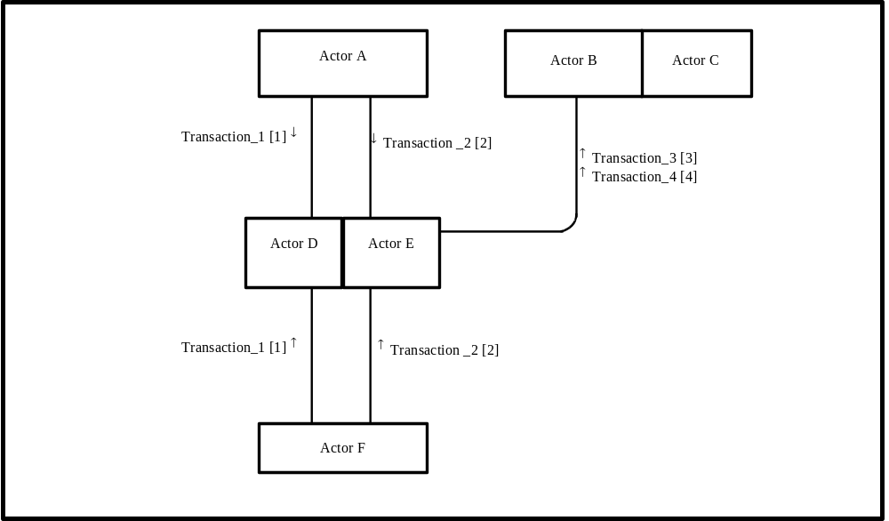
Figure X.1-1. <Profile Name> Actor Diagram
Table X.1-1 lists the transactions for each actor directly involved in the <Profile Name> Profile. In order to claim support of this Integration Profile, an implementation must perform the required transactions (labeled “R”). Transactions labeled “O” are optional. A complete list of options defined by this Integration Profile and that implementations may choose to support is listed in Volume I, Section X.2.

Table X.1-1. <Profile Name> Integration Profile - Actors and Transactions
Actors | Transactions | Optionality | Section in Vol. 2
Actor A | Transaction_1 | R | Z.1
Actor A | Transaction_2 | R | Z.2
Actor F | Transaction_1 | R | Z.1
Actor F | Transaction_2 | R | Z.2
Actor D/ Actor E | Transaction_1 | R | Z.1
Actor D/ Actor E | Transaction_2 | R | Z.2
Actor D/ Actor E | Transaction_3 | R | Z.3
Actor D/ Actor E | Transaction_4 | R | Z.4
Actor B (Actor C) | Transaction_3 | R | Z.3
Actor B (Actor C) | Transaction_4 | R | Z.4
Note: This is a note

X.2 Nursing Summary Integration Profile Options
<Table describing the options available for this integration profile and references to all sections that state requirements for compliance to the Option.>
Options that may be selected for this Integration Profile are listed in the table X.2-1 along with the Actors to which they apply. Dependencies between options when applicable are specified in notes.
Table X.2-1 <Profile Name> - Actors and Options
Actor | Options | Vol & Section
Actor A | No options defined | - -
Actor F | No options defined | - -
Actor D/ Actor E | No options defined | - -
Actor D/ Actor E | No options defined | - -
Actor B (Actor C) | No options defined | - -
Actor B (Actor C) | No options defined | - -

X.3 Nursing Summary Process Flow

3.1 Use Case: Acute Care to Home Care
Current flow:The Home Care Nurse (HCN) admits a patient, Ann, who is newly diagnosed with Diabetes Mellitus (DM) during a hospital admission for a Myocardial Infarction (MI). Ann is experiencing increased anxiety related to her fear of sudden death due to potential of subsequent MI. The HCN finds it difficult to teach Ann and provide the education needed for Ann to heal and manage her disease processes. No information regarding ways Ann learns most effectively, skills and evaluation relating to blood sugar monitoring, signs and symptoms of cardiac change or follow-up appointment with Ann’s primary care physician has been provided to home health agency or primary care office.
Proposed flow: Medical summary will be provided to the HCN with referral prior to discharge. Nursing summary, prepared by discharging nurse (DN), indicates Ann’s anxiety is focused on MI due to sudden death of a friend with MI 10 months ago. Ann has had difficulty with learning about diabetes as she has not recognized symptoms of DM and believes the metformin prescribed will cure her elevated blood sugars. Ann has demonstrated successful use of glucometer twice during her hospital stay. Hgb AIC 12.8 and she will need significant education about DM as well as MI. Ann lives alone in two story house with bedroom and bathroom upstairs only. Ann has no relatives in area and inadequate financial support.

Based on referral containing medical and nursing summary of Ann’s response in hospital, HCN is able to plan interventions individualized to Ann. Education related to physiologic condition and individual response to DM and MI is provided. Cardiac rehab will start immediately. Transportation to Cardiac Rehab will be arranged. HCN will assist Ann to monitor blood glucose and provide medication information. HCN will increase MI and DM education as Ann tolerates. HCN will refer to support agencies for patient safety and financial resources. Ann will be referred to a Food Bank to stretch food dollars and ensure healthy nutrition.

The outcome of the Nursing summary is that Ann will receive the care management follow-up needed to meet goals, minimize risk of future MI, manage and minimize complications of DM. Ann will attend Cardiac Rehab support due to provision of transportation.

3.1.1 Date elements: Acute Care to Home Care
Use Case Document Section | PCC Section | Constraint
Name
Date of Admission
Date of Discharge
Diagnosis
Hospital Course
Code Status
Emergency Contact
Durable Power of Attorney
Advanced Directive
Allergies and adverse reactions
Vital Signs
Medications
Fall Risk
Pain
Abnormal Assessment findings
Abnormal Lab findings
Plan of care
Nursing Interventions
Patient Education
Primary Care Physician
Specialty Physician
Other referrals
Reporting Nurse/date/time
Accepting Nurse/date/time

3.2 Use Case: Perioperative to PACU
Patient admitted from the Operating Suite to Post Anesthesia Care Unit after knee replacement surgery. Reporting nurse provides these data elements.

Use Case Document Section | Constraint
Name
Age
Gender
Surgical Procedure
Surgeon
Anesthesiologist
Allergies
Medical History
Surgical History
Vital Signs
Catheters
Drains
Tubes
Medications
Intravenous lines
Total Fluids
Hemodynamic measuring lines present
Total Outputs including Estimated Blood Loss (EBL)
Counts
Incisions/dressings
Specimens
Plan of Care
Reporting Nurse/date/time
Accepting Nurse/date/time
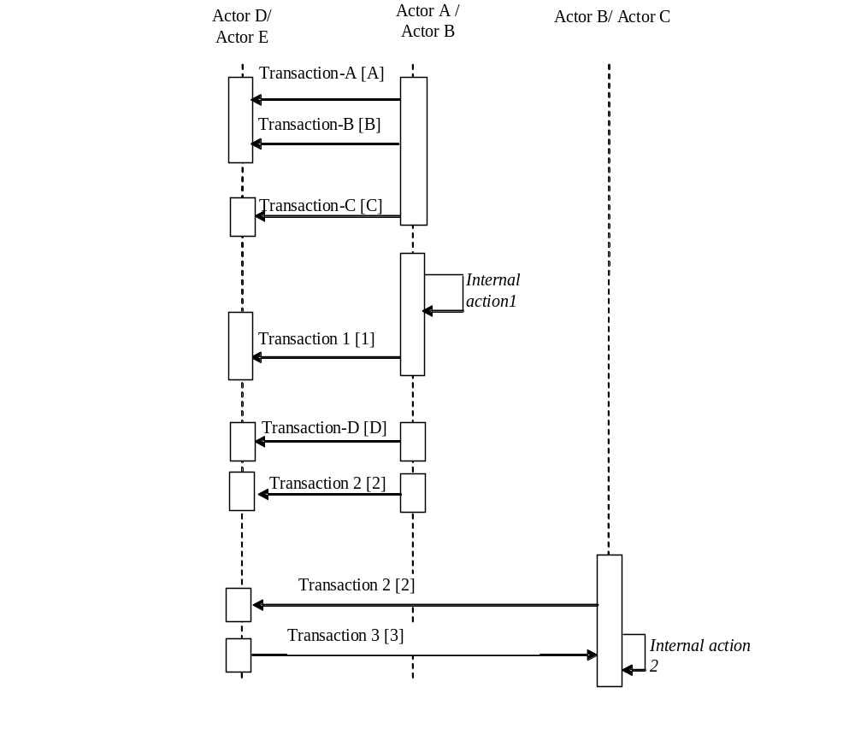Figure X.2-1. Basic Process Flow in <Profile Name> Profile

X.4 <Profile Name> Security Considerations
<Description of the Profile specific security considerations. This should include the outcomes of a risk assessment. This likely will include profile groupings, and residual risks that need to be assigned to the product design, system administration, or policy.>
<Appendix A> Actor Summary Definitions
<add any actor definitions for new actors defined specifically for this profile>
<Appendix B> Transaction Summary Definitions
<add any transaction definitions for new transactions defined specifically for this profile>

Glossary
Add the following terms to the Glossary:
<any glossary additions associated with the profile draft go here>

Volume 2 - Transactions
Add section 3.Y

3.Y <Transaction Name>
This section corresponds to Transaction Y of the IHE Technical Framework. Transaction Y is used by the <ABC> and <DEF> actors.

3.Y.1 Scope

3.Y.2 Use Case Roles
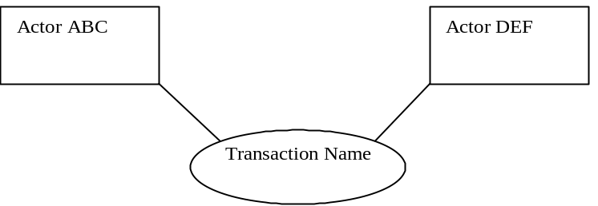

Actor:
Role:
Actor:
Role:
Actor:
Role: .

3.Y.3 Referenced Standard
<e.g., HL7 2.3.1 Chapters 2, 3>
<e.g. DICOM 2008 PS 3.3: A.35.8 X-Ray Radiation Dose SR IOD>

3.Y.4 Interaction Diagram
<the interaction diagram shows the detailed standards-based message exchange that makes up the IHE transaction>
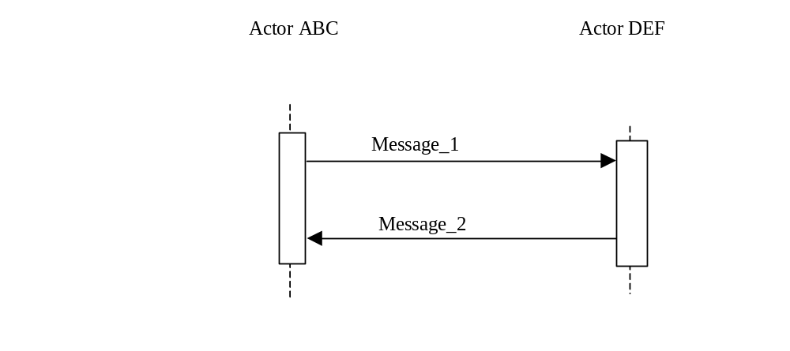

3.Y.4.1 <Message_1 Name>
<One or two sentence description of the first message of the above interaction diagram, typically relating the message to the relevant standard>

3.Y.4.1.1 Trigger Events
<description of the real world events that cause the initiation of the first message>

3.Y.4.1.2 Message Semantics
<detailed description of the meaning, structure and contents of the first message including any IHE specific clarifications of the message format, attributes, etc.>

3.Y.4.1.3 Expected Actions
<description of the actions expected to be taken as a result of sending or receiving this message>

3.Y.4.2 <Message_2 Name>
<One or two sentence description of the the next message in the above interaction diagram, typically relating the message to the relevant standard. Note, repeat this section as necessary based on the number of messages in the interaction diagram>

3.Y.4.2.1 Trigger Events
<description of the real world events that cause the initiation of the next message>

3.Y.4.2.2 Message Semantics
<detailed description of the meaning, structure and contents of the next message including any IHE specific clarifications of the message format, attributes, etc.>

3.Y.4.2.3 Expected Actions
<description of the actions expected to be taken as a result of sending or receiving this message>

3.Y.5 Security Considerations
<description of the transaction specific security consideration. Such as use of security profiles. >

3.Y.5.1 Security Audit Considerations
<This section should specifiy any specific ATNA security audit event that is associated with this transaction and requirements on the encoding of that audit event. >

3.Y.5.1.(z) Actor Specific Security Considerations
<This section should specifiy any specific security considerations on an Actor by Actor basis.>
<Appendix letter> Appendix_Name
<Detailed cross transaction relationships or mapping details are described in an appendix in Volume 2>

